

**Assessment 1 – Research and Questioning**

# Assessment –

# Research & Questioning

|  |  |  |  |
| --- | --- | --- | --- |
| **Name of Student** | **MAIARA CRISTINA DOS SANTOS** | **ID** | **18232** |

Contents

Assessment – 1

Research & Questioning 1

View My Web Support: 1

***Instructions:*** 2

***Business Scenario*** 3

**Task 1: Determine support areas** 3

***Task 2: Identify stakeholders*** 5

***Task 3: Develop support procedures*** 5

***Task 4: Assign Support Personnel*** 6

***Task 5: Short Answer Questions*** 6

***Task 6: Multiple Choice Questions*** 8

Index 14

#### 

#### View My Web Support:

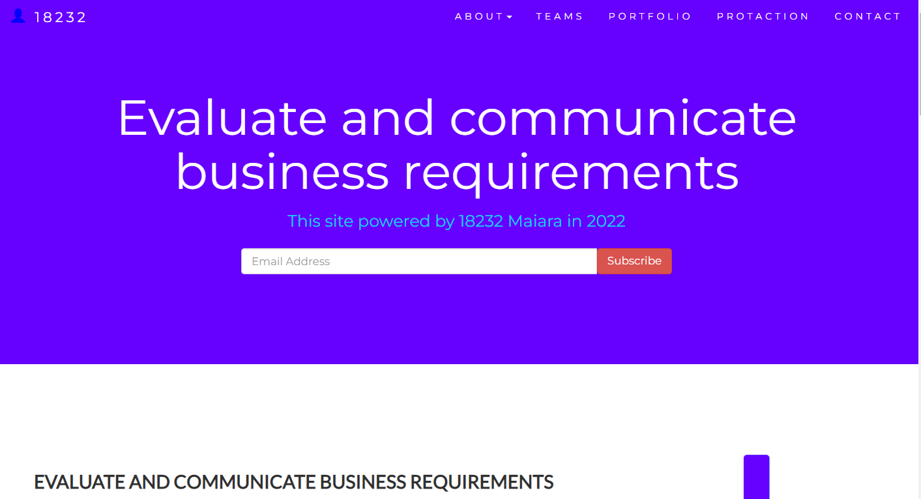

#### *Instructions:*

This assessment is to be completed individually. In this assessment you will be working through a number of written tasks based on case scenarios or research that relate directly to each element of competency for this cluster. Outlined below is information on how each of the tasks relates the element of competency covered.

Learn how to make Google Form: <https://www.youtube.com/watch?v=BtoOHhA3aPQ&t=4s>

Your tasks:

#### *Business Scenario*

D&K Books Pty Ltd is a bookstore owned by Mr. Dean Kerr. The business occupies two levels of an office building connected by escalators and lifts. D&K Books employs approximately six sales staff, one operation manager, two administrative officers, a bookkeeper and a marketing manager. They have an Ethernet network consisting of ten PCs (Intel I3 Desktop cloned), two switches, a router and three printers. They use the QuickBooks software to manage their entire business, including sales, inventory, ordering, accounts receivable, accounts payable, payroll and employee management. They also have two EFTPOS terminals one on each floor.

D&K Books has a Linux server that stores all of the data including the QuickBooks database. The server is backed up to tape regularly. They also have a website (hosted on an Australian ISP’s server, dynamic and static pages using asp.net) on which customers can browse the product catalogue and view current specials. They also lease a telephone system from Live Telecoms. The PABX (phone system) consists of a main switchboard and five remote phones with three incoming lines and a message-on-hold queue system.

#### http://imapwebsolutions.com/wp-content/uploads/2014/07/linux-dedicated-server.pngTask 1: Determine support areas

Identify information technology (HW and SW) and list the technology in use in D&K Books and consider the following:

* What sort of support does the technology require?
* Who is likely to provide this support?
* Does the support arrangement already exist?

**Present your answer in a table such as the one below:**

|  |  |  |  |  |
| --- | --- | --- | --- | --- |
| **Technology** | **Description** | **Support Required** | **Provider** | **Support Already exists? (Yes/No)** |
| **QuickBooks Software** | software that keeps track of all accounts, stock, GST, etc. | customisation, training, upgrades, bug fixes (patching), user support | [www.intuit.com.au](http://www.intuit.com.au)  online to find more | No |
| **Computers** | Intel I3 Desktop cloned | upgrades, repairs, troubleshooting, maintenance, backup, customisation, network to link |  | No. Need find one person to do this job |
| **Server** | Linux Server with tape backup  May need upgrade to hard disk backup | User account management, security policy implementation, home folder management, permissions management, backup and restore, operating system patching, software installation |  | No |
| **EFTPOS** | Easy to use | No need | shop | Yes |
| **Telephone system** | Low cost | Phone company | Telstra | Yes |
| **Website** | Low cost | Yes | Godaddy | Yes |
| **Network** | wireless | No external | No | No |

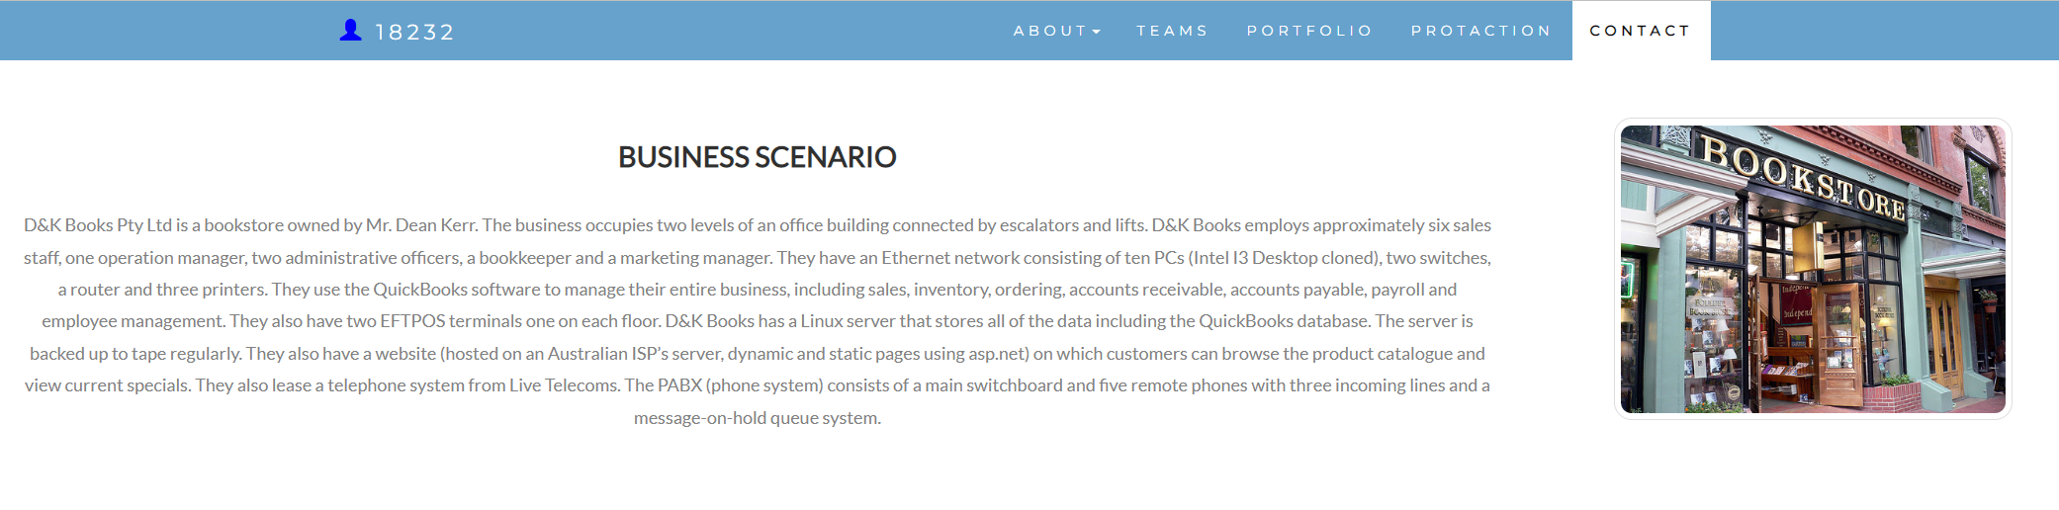

#### *Task 2: Identify stakeholders*

**Identify stakeholders related in D&K Books system**

All the Employees, Providers, Customers, Investors.

Examples of stakeholders include the project manager, project sponsor, higher management, and team members.

#### *Task 3: Develop support procedures*

1. Describe one positive and one negative experience you have had when seeking assistance from a telecommunication company, an ISP or a computer supplier. Your experience may be via telephone, email or even voice recognition.

|  |  |  |
| --- | --- | --- |
| Type | Positive | Negative |
| Telephone | Easy to get answer | Document provide |
| Email | Document, Picture, words or any media | Have to wait |
| Go to company | Face to face get answer | Cost time and money on trip |
| When we contact a company | solve the problem | not solve the problem |

1. Using the experiences described above please answer the following questions.
   1. What support aspects were professional and/or unprofessional?
   2. How long did the support process take?
   3. Were the steps logical?
   4. Did they solve your problem?
   5. Was the call deflected to another area?

|  |  |  |
| --- | --- | --- |
| Items | Professional | Unprofessional |
| What support aspects | Communication skills | Poor work ethic |
| How long | Very quick | Waiting and waiting |
| Steps logical | Yes | No |
| Solve | Good | Can not |
| Another area | If has, need solve | If has, do not care |

#### *Task 4: Assign Support Personnel*

Classify the following into soft skills and technical skills. Your answer should take the form of a table shown below.

|  |  |  |
| --- | --- | --- |
| **Skill** | **Soft skill** | **Technical skill** |
| A knowledge of Linux | X |  |
| The ability to work under pressure | X |  |
| The administration of Windows 2008 Server |  | X |
| The ability to formulate network and IT policies | ? | ? |
| The ability to write network documentation | ? | ? |
| The ability to give presentations | ? | ? |

#### *Task 5: Short Answer Questions*

1. **Explain the relationship between data, information and knowledge.**

***Data*** are the raw alphanumeric values obtained through different acquisition methods. Data in their simplest form consist of raw alphanumeric values.

***Information*** is created when data are processed, organized, or structured to provide context and meaning. Information is essentially processed data.

***Knowledge*** is what we know. Knowledge is unique to each individual and is the accumulation of past experience and insight that shapes the lens by which we interpret, and assign meaning to, information. For knowledge to result in action, an individual must have the authority and capacity to make and implement a decision. Knowledge (and authority) are needed to produce actionable information that can lead to impact.

1. **What is quantitative data and how can you use it.**

Quantitative data are used when a researcher is trying to quantify a problem, or address the "what" or "how many" aspects of a research question. It is data that can either be counted or compared on a numeric scale

1. **What is qualitative data and how can you use it.**

Qualitative data is used when you need to determine the particular trends of traits or characteristics or to form parameters for larger data sets to be observed. Qualitative data provides the means by which analysts can quantify the world around them.

1. **Give an example of how quantitative and qualitative data can be used in conjunction with each other.**

In reality, they complement each other, however, resulting in deeper insights. Think of qualitative and quantitative as the “yin and yang” of research – they work fine on their own but they deliver deeper and more useful insights when used in combination.

1. What sort of methods could you use to determine client requirements for a website design and key information sources?
2. **Give some examples of client requirements for a website design**

* Website Design Requirements. Your idea and vision for the project is arguably the most important part of the whole preparation process
* Colour Scheme
* Fonts
* Website Content Requirements
* Images
* Mock-ups
* Text Content
* Logo.

#### *Task 6: Multiple Choice Questions*

1. Generally, how many points should a rating scale have?
   1. Five
   2. Four
   3. Ten
   4. **Somewhere from 4 to 11 points**

Comment: Rating scale is defined as a closed-ended survey question used to represent respondent feedback in a comparative form for specific particular features/products etc.

1. What is the problem(s) with this set of response categories to the question “What is your current age?”

* 1-5
* 5-10
* 10-20
* 20-30
* 30-40
  1. The categories are not mutually exclusive
  2. The categories are not exhaustive
  3. **Both a and b are problems**
  4. There is no problem with the above set of response categories

1. You should mix methods in a way that provides complementary strengths and no overlapping weaknesses. This is known as the fundamental principle of mixed research.
   1. **True**
   2. False

Comment: You should mix methods in a way that provides complementary strengths and non-overlapping weaknesses

1. According to the text, questionnaires can address events and characteristics taking place when?
   1. In the past (retrospective questions)
   2. In the present (current time questions)
   3. In the future (prospective questions)
   4. **All of the above**
2. Which of the following are principles of questionnaire construction?
   1. Consider using multiple methods when measuring abstract constructs
   2. Use multiple items to measure abstract constructs
   3. Avoid double-barrelled questions
   4. All of the above
   5. **Only b and c**
3. Which of these is not a method of data collection?
   1. Questionnaires
   2. Interviews
   3. **Experiments**
   4. Observations
4. Secondary/existing data may include which of the following?
   1. Official documents
   2. Personal documents
   3. Archived research data
   4. **All of the above**
5. An item that directs participants to different follow-up questions depending on their response is called a ____________.
   1. Response set
   2. Probe
   3. Semantic differential
   4. **Contingency question**
6. Which of the following terms best describes data that were originally collected at an earlier time by a different person for a different purpose?
   1. Primary data
   2. **Secondary data**
   3. Experimental data
   4. Field notes
7. Researchers use both open-ended and closed-ended questions to collect data. Which of the following statements is true?
   1. Open-ended questions directly provide quantitative data based on the researcher’s predetermined response categories
   2. Closed-ended questions provide quantitative data in the participant’s own words
   3. **Open-ended questions provide qualitative data in the participant’s own words**
   4. Closed-ended questions directly provide qualitative data in the participants’ own words
8. Open-ended questions provide primarily ______ data.
   1. Confirmatory data
   2. **Qualitative data**
   3. Predictive data
   4. None of the above
9. Which of the following is true concerning observation?
   1. It takes less time than self-report approaches
   2. It costs less money than self-report approaches
   3. **It is often not possible to determine exactly why the people behave as they do**
   4. All of the above
10. Qualitative observation is usually done for exploratory purposes; it is also called ___________ observation.
    1. Structured
    2. **Naturalistic**
    3. Complete
    4. Probed
11. When constructing a questionnaire, it is important to do each of the following except ______.
    1. **Use "leading" or "loaded" questions**
    2. Use natural language
    3. Understand your research participants
    4. Pilot your test questionnaire
12. Another name for a Likert Scale is a(n):
    1. Interview protocol
    2. Event sampling
    3. **Summated rating scale**
    4. Ranking
13. Which of the following is not one of the six major methods of data collection that are used by educational researchers?
    1. Observation
    2. Interviews
    3. Questionnaires
    4. **Checklists**
14. The type of interview in which the specific topics are decided in advance but the sequence and wording can be modified during the interview is called:
    1. **The interview guide approach**
    2. The informal conversational interview
    3. A closed quantitative interview
    4. The standardized open-ended interview
15. Which one of the following in not a major method of data collection:
    1. Questionnaires
    2. **Interviews**
    3. Secondary data
    4. Focus groups
    5. All of the above are methods of data collection
16. A question during an interview such as “Why do you feel that way?” is known as a:
    1. **Probe**
    2. Filter question
    3. Response
    4. Pilot
17. A census taker often collects data through which of the following?
    1. Standardized tests
    2. Interviews
    3. Secondary data
    4. **Observations**
18. The researcher has secretly placed him or herself (as a member) in the group that is being studied. This researcher may be which of the following?
    1. **A complete participant**
    2. An observer-as-participant
    3. A participant-as-observer
    4. None of the above
19. Which of the following is not a major method of data collection?
    1. Questionnaires
    2. Focus groups
    3. **Correlational method**
    4. Secondary data
20. Which type of interview allows the questions to emerge from the immediate context or course of things?
    1. Interview guide approach
    2. **Informal conversational interview**
    3. Closed quantitative interview
    4. Standardized open-ended interview
21. When conducting an interview, asking "Anything else?, What do you mean?, Why do you feel that way?," etc, are all forms of:
    1. Contingency questions
    2. **Probes**
    3. Protocols
    4. Response categories
22. When constructing a questionnaire, there are 15 principles to which you should adhere. Which of the following is not one of those principles?
    1. Do not use "leading" or "loaded" questions
    2. Avoid double-barrelled questions
    3. Avoid double negatives
    4. **Avoid using multiple items to measure a single construct**
23. A customer-based Service Level Agreement structure includes:
    1. An SLA covering all Customer groups and all the services they use
    2. SLAs for each service that are Customer-focused and written in business language
    3. An SLA for each service type, covering all those Customer groups that use that Service
    4. **An SLA with each individual Customer group, covering all of the services they use**
24. Which of the following best describes the goal of Service Level Management?
    1. **To maintain and improve IT service quality in line with business requirements**
    2. To provide IT services at the lowest possible cost by agreeing with Customers their minimum requirements for service availability and ensuring performance does not exceed these targets
    3. To provide the highest possible level of service to Customers and continuously improve on this through ensuring all services operate at maximum availability
    4. To ensure that IT delivers the same standard of service at the least cost
25. The process to implement SLAs comprises of the following activities in sequence:
    1. Draft SLAs, catalogue services, review underpinning contracts and OLAs, draft SLRs, negotiate, agree SLAs
    2. Draft SLAs, review underpinning contracts and OLAs, negotiate, catalogue services,
    3. Review underpinning contracts and OLAs, draft SLAs, catalogue services, negotiate, agree SLAs
    4. **Catalogue services, establish SLRs, review underpinning contracts and OLAs, negotiate service levels, agree SLAs**
26. Which of the following is an example of a service level agreement (SLA) between information systems support unit and a research unit in the laboratories of a large company?
    1. The maximum response time to get the system operational should it fail.
    2. The minimum ‘up-time’.
    3. The types of information that will be provided as standard.
    4. **All of the above.**
27. Some organisations bring a degree of formality to the internal customer concept by encouraging (or requiring) different parts of the operation to agree on:
    1. Internal service agreements
    2. **Service level agreements**
    3. Formal provision agreements
    4. Delivery agreements

My Preview website

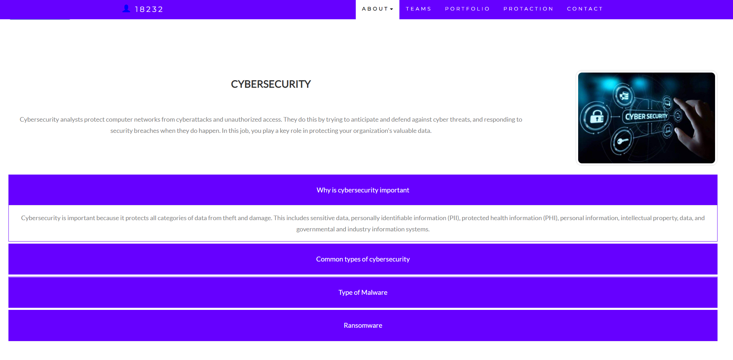

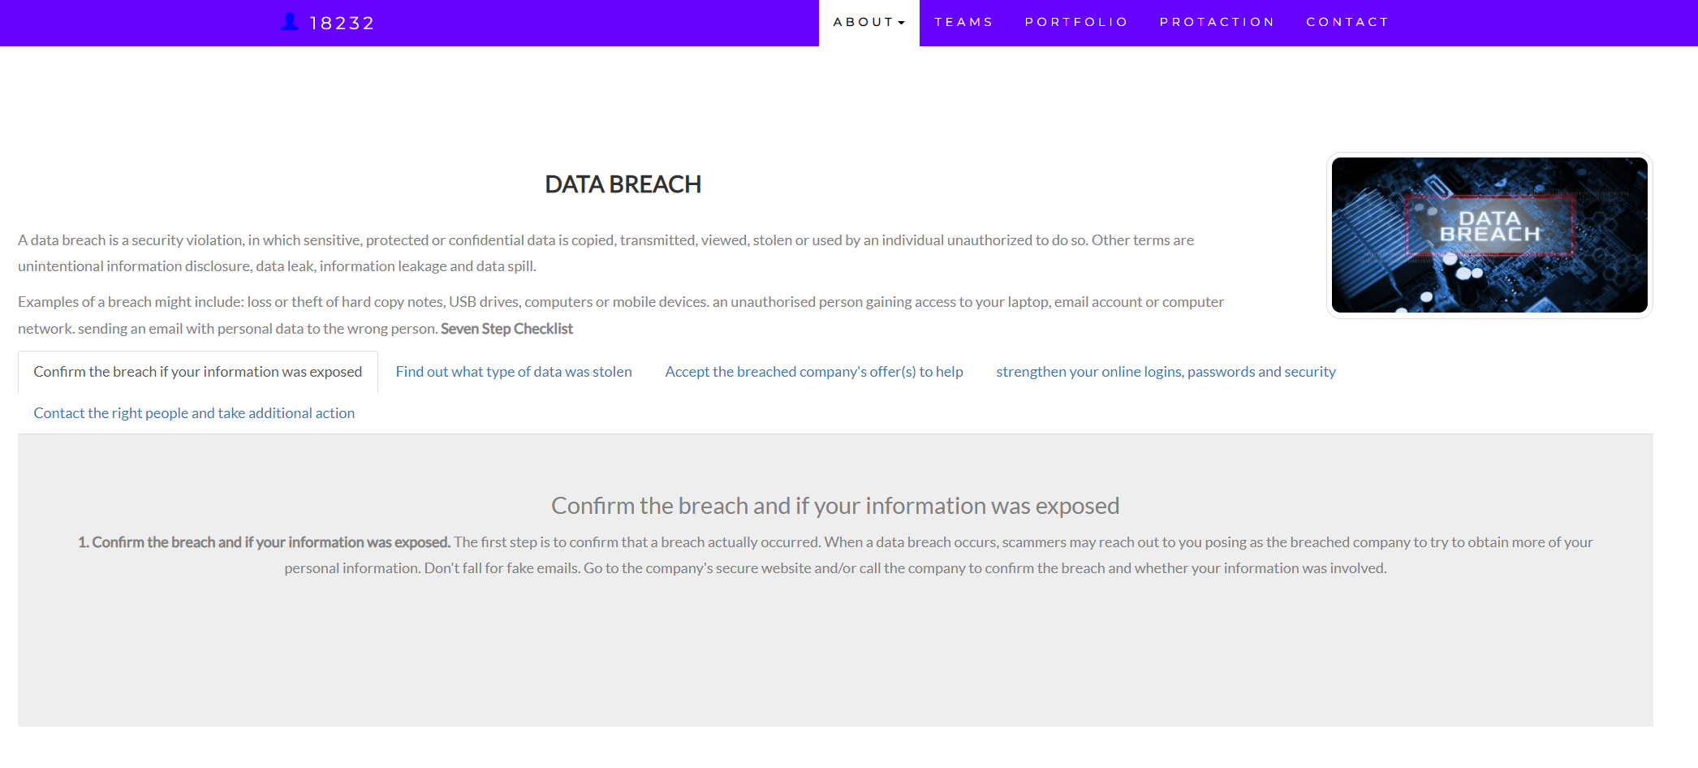

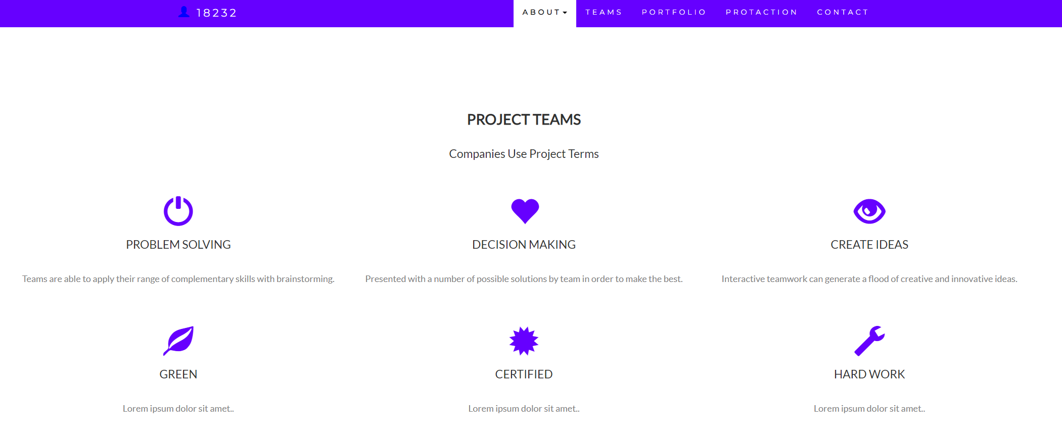

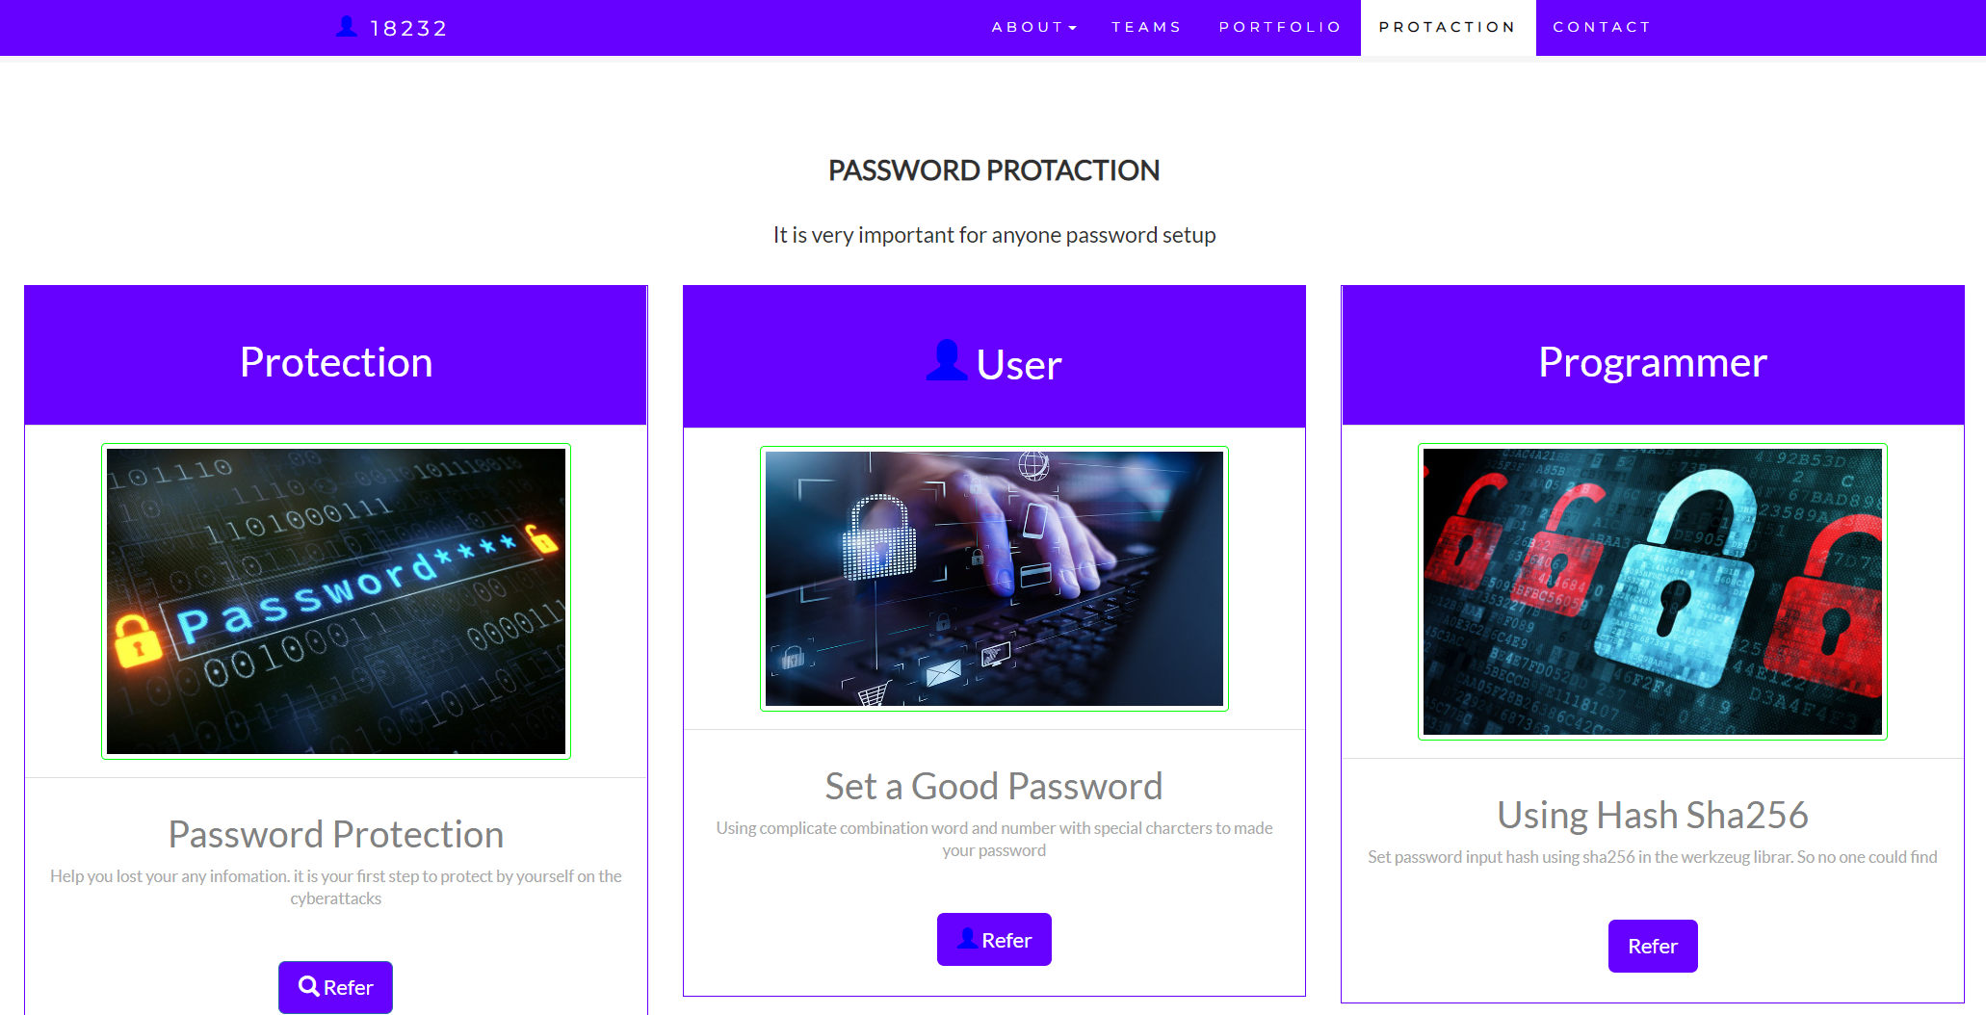

## Index

B

bookstore 1

C

categories 6

closed-ended 7

D

data collection 9

L

Linux server 2

N

network 1

O

open-ended 7

S

Service Level 9

service level agreement 10

service quality 10

soft skills 5

support 3

T

technology 2

telecommunications 3